
Toyota Yaris GR FMINDL1 FITTING INSTRUCTIONS

Please thoroughly read through and familiarise yourself with these instructions in their entirety prior to beginning any part of the installation process of any component. Please also ensure the vehicle and engine has cooled down sufficiently to avoid risking possible skin burns or other injury.

TOOLS NEEDED:
7mm/10mm socket and ratchet
Long nose pliers
Flat blade screwdriver or trim tool

- Open the bonnet and locate 2x plastic fasteners securing the air duct to the air box. Using a flat blade screwdriver release both fasteners, this will allow you to remove the air duct.

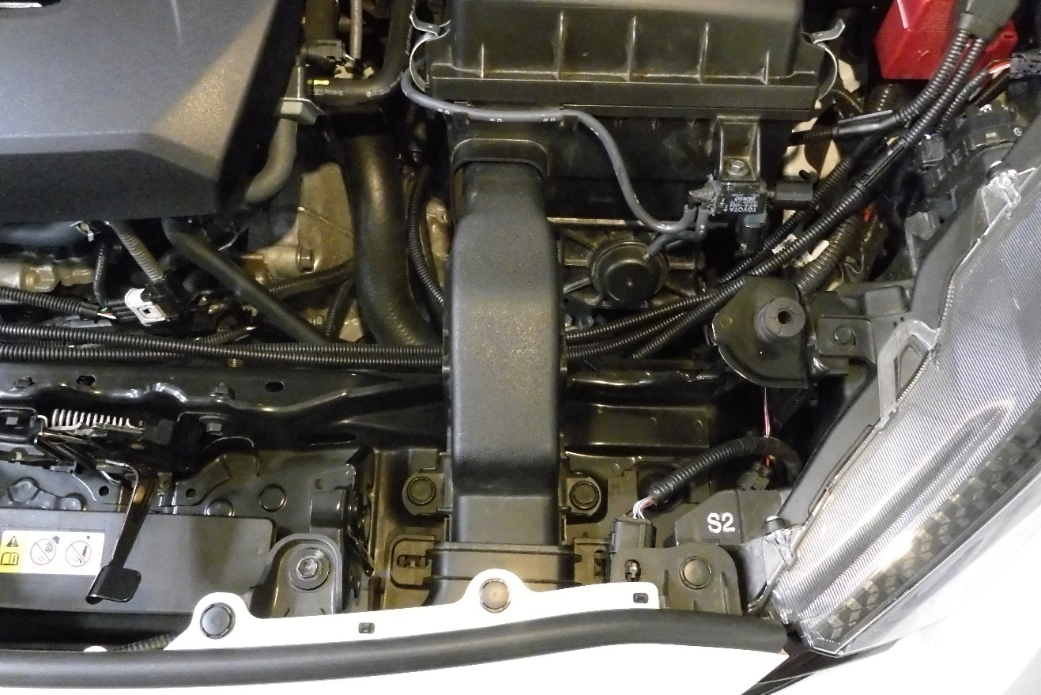

- Using some long nose plyers pinch the retaining tabs securing the OEM air scoop allowing you to remove it from the vehicle. Disconnect the wiring loom from the bumper in the same way.

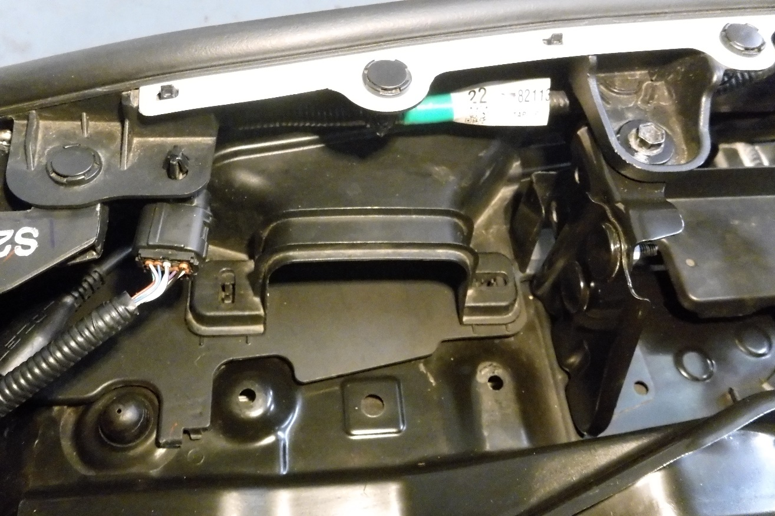
- Using a 7mm socket and ratchet for a Forge Hose or 10mm socket and ratchet for a OEM hose loosen both hose clamps of the inlet hose, this will allow you to remove the hose from the airbox. Press in the retaining tab on the MAF loom and unplug it from the MAF.

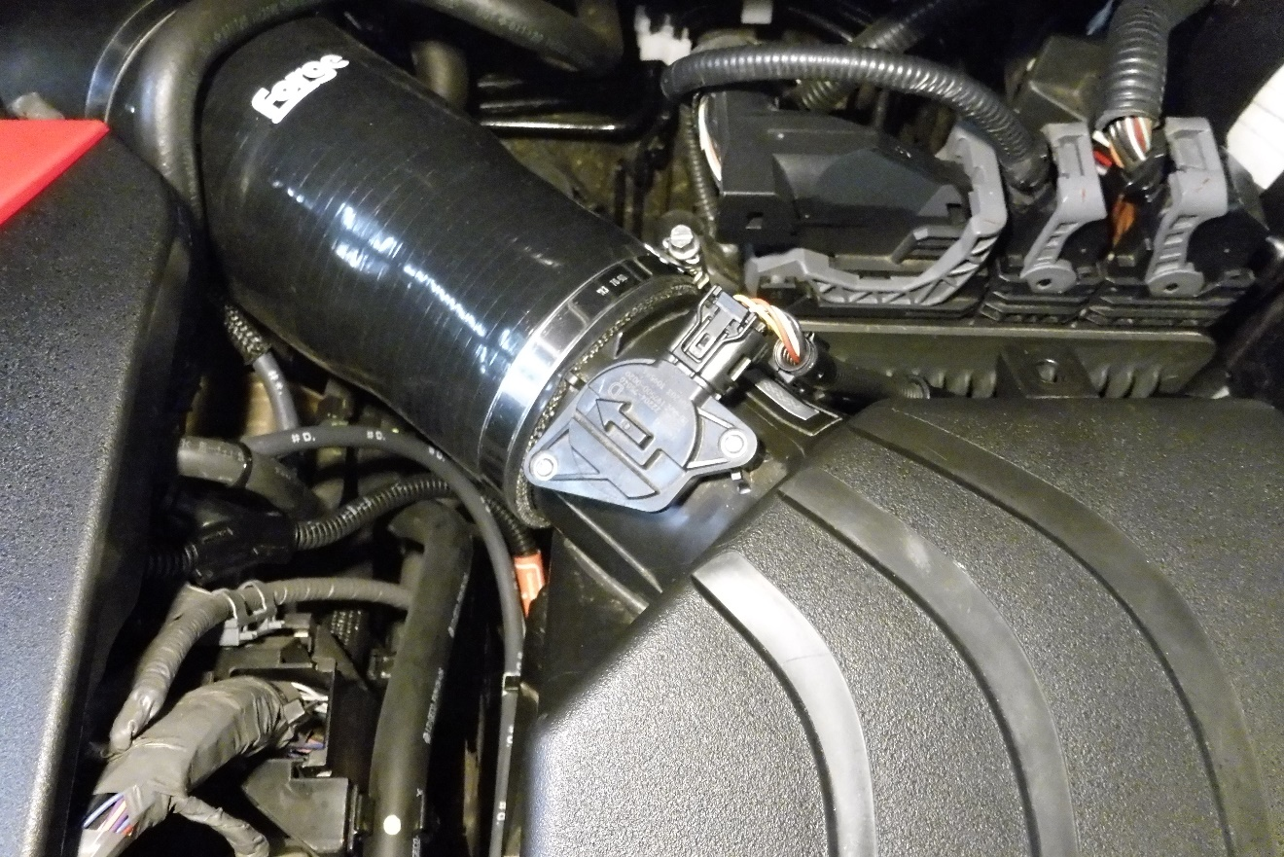

- Disconnect the vacuum hose from the airbox, and from the airbox pump.

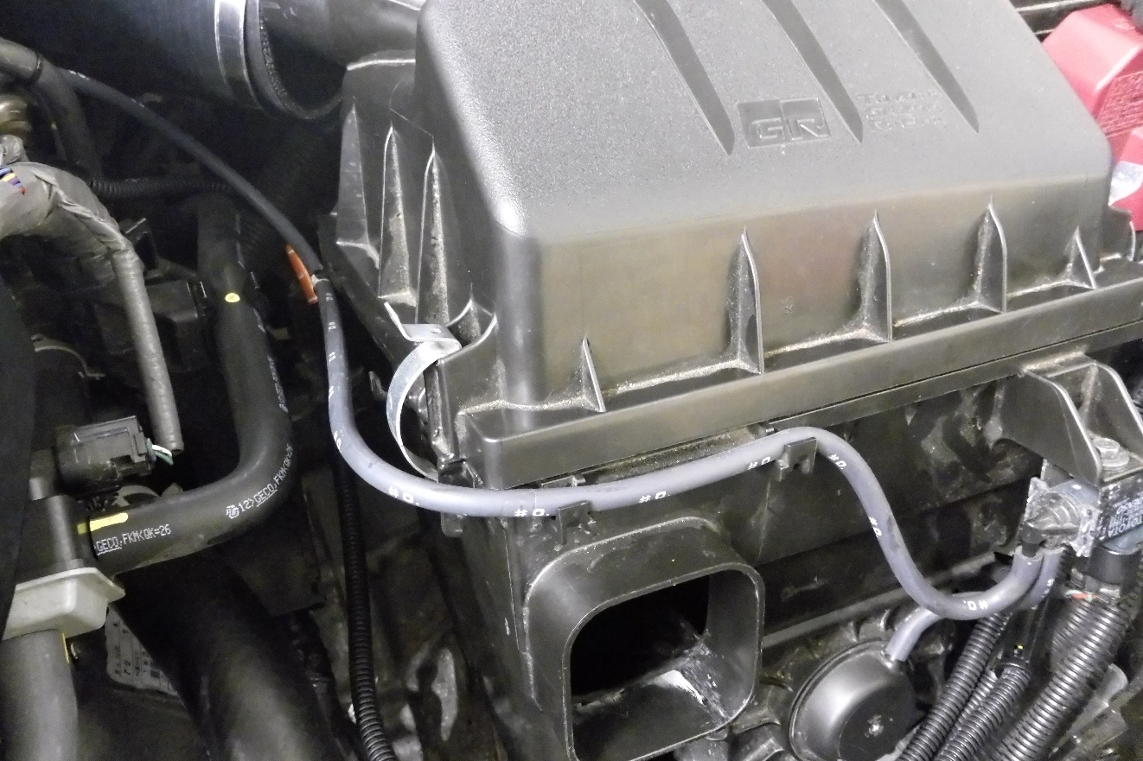

- Push the retaining tab inwards on the loom to the airbox pump and unplug from the pump, then unclip the loom which is attached to the airbox. The airbox will now pull out of the engine bay.

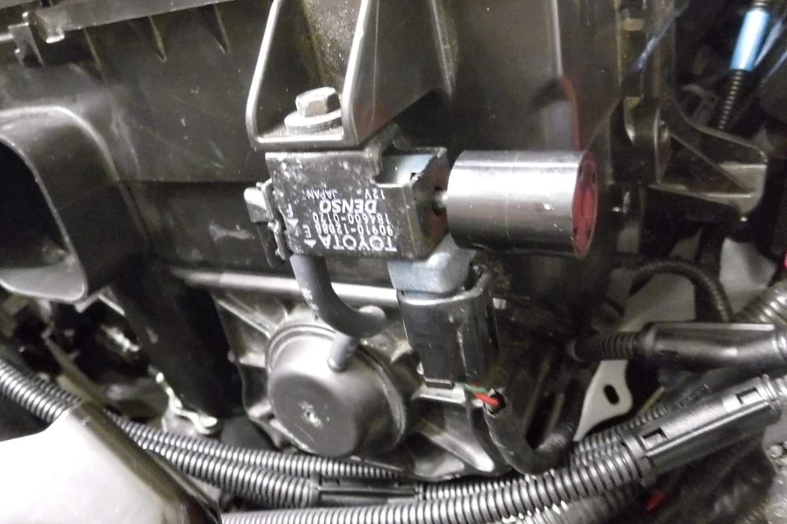

- Take the Forge Motorsport inlet duct and place it into position. The first picture shows where the fastening points should be located.

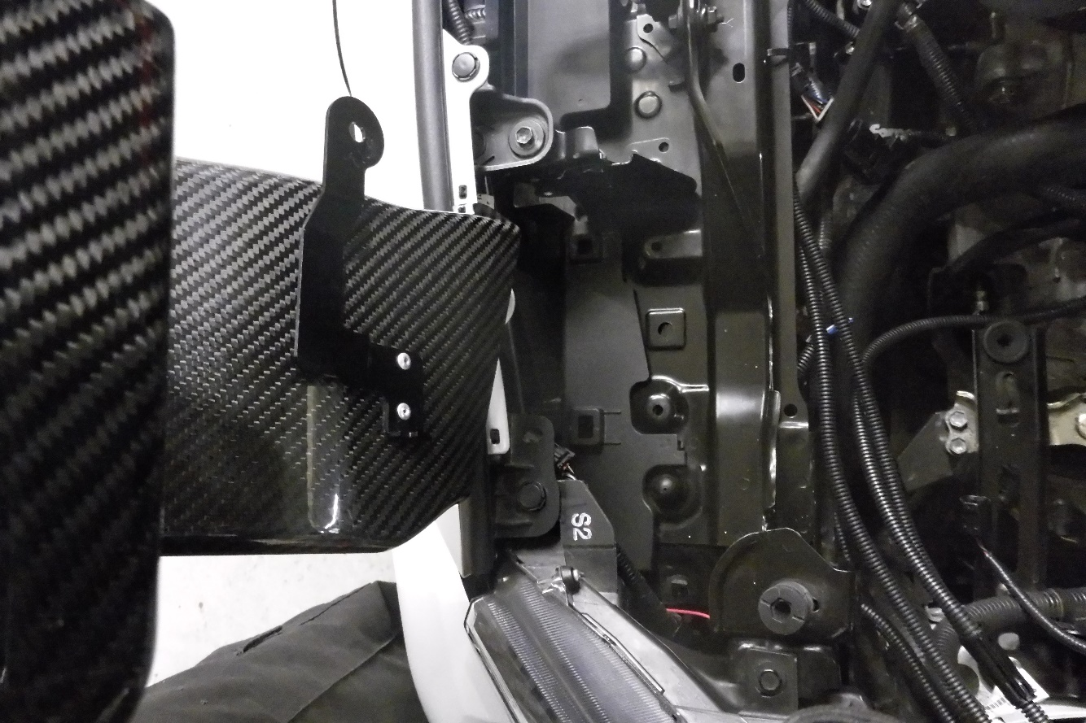
- With the air duct in position make sure not to cover the rubber grommet for the airbox. Do not to fix the inlet duct into position at this stage.

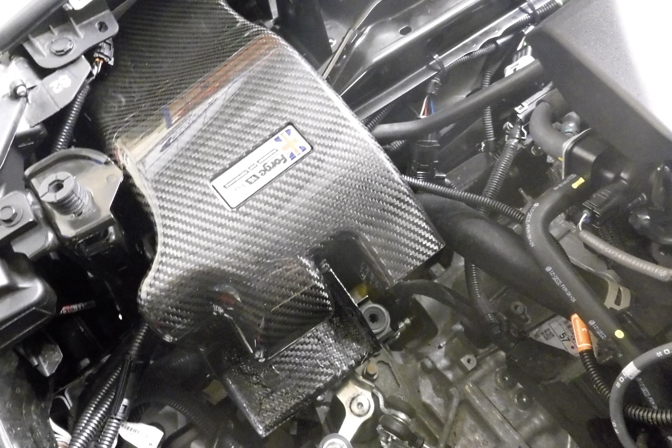

- When re-installing the airbox re-attach the vacuum pipe to the airbox first.

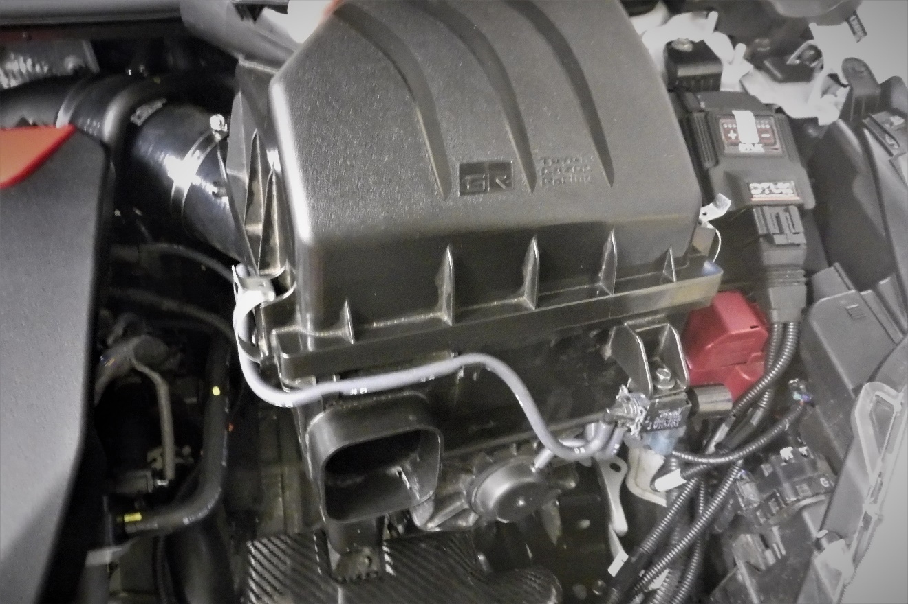
Shorter shift
Longer shift

- Insert the inlet duct into the airbox opening and then follow steps 3-5 in reverse.

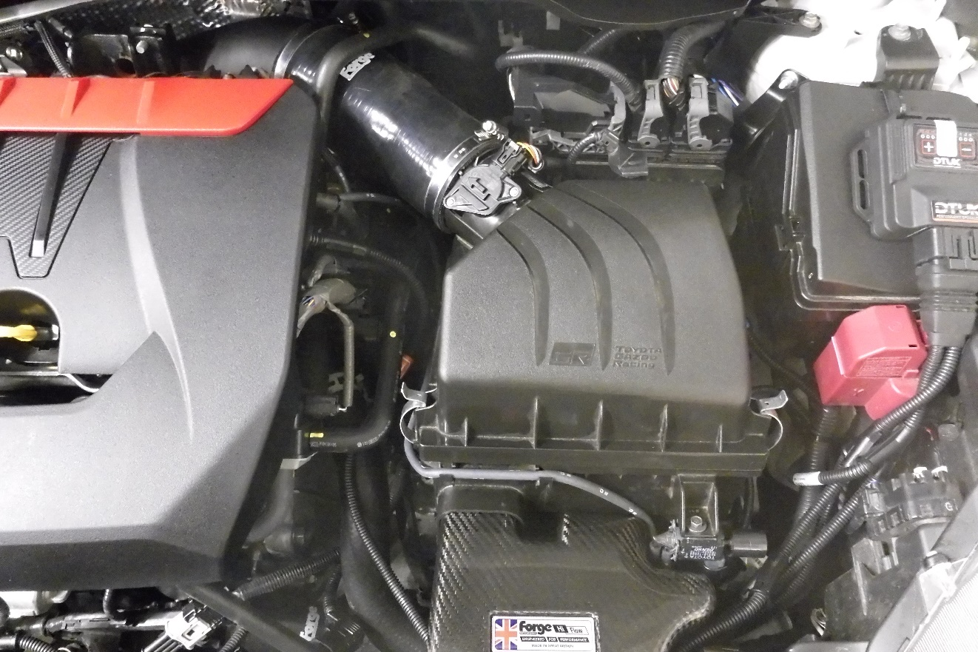

- With the airbox re-installed secure the Forge inlet duct using one of the original plastic fasteners. The remaining fastener is not used.

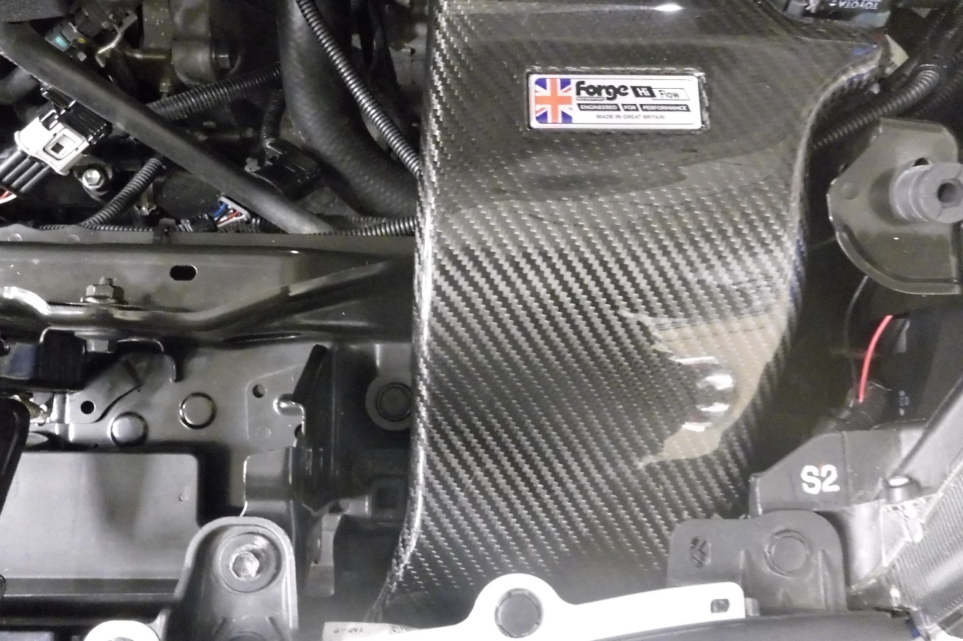

- Tuck the bumper wiring loom to the side of the inlet duct.

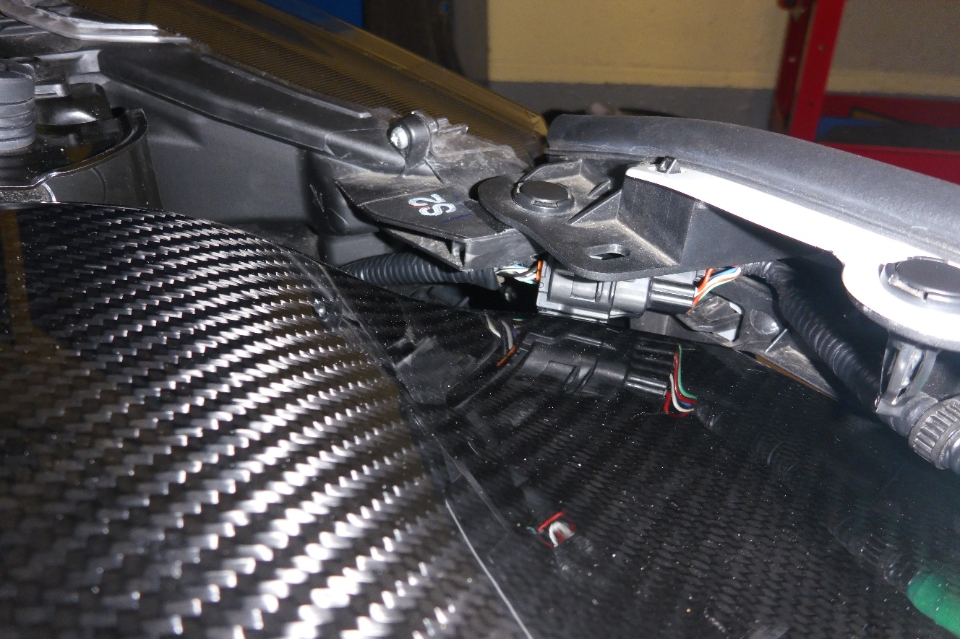

- The installation for FMINLD-1 is now complete, take your vehicle for a test drive and enjoy your new Forge Motorsport product.

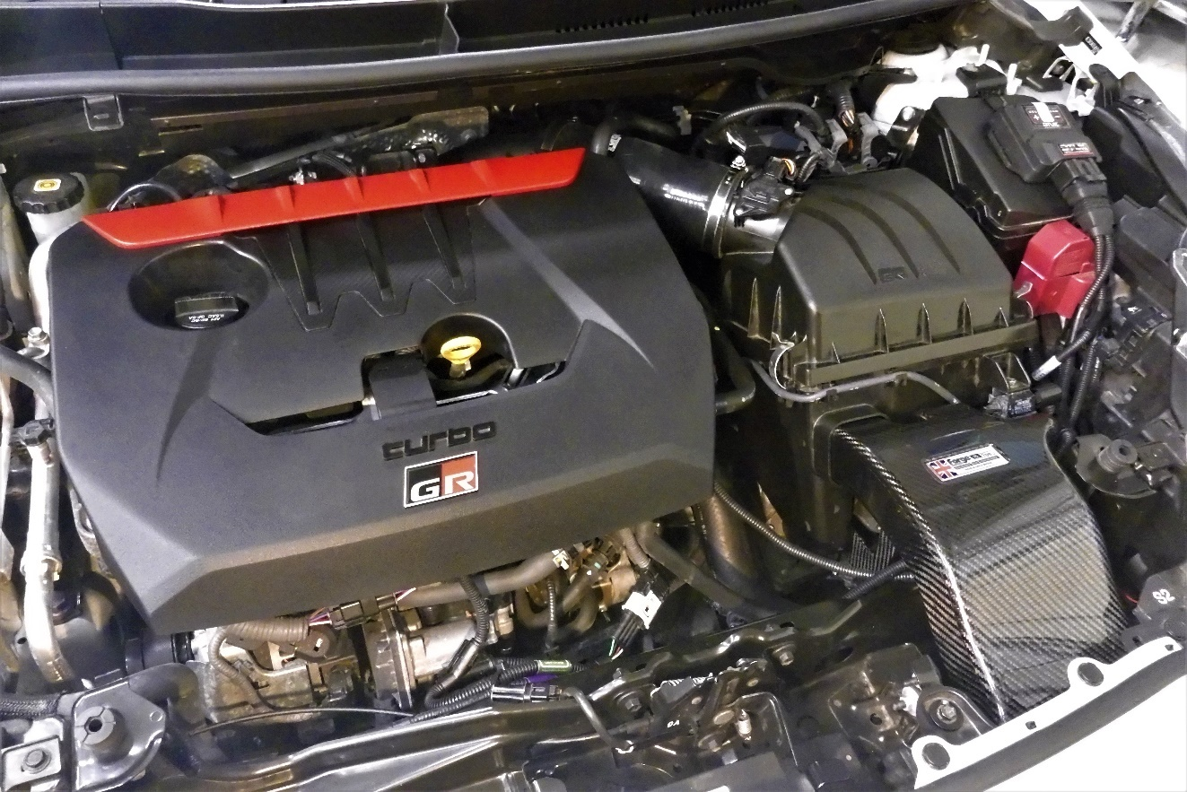

Check out WWW.FORGEMOTORSPORT.CO.UK and WWW.FORGEMOTORSPORT.COM
For a full range of performance products for your vehicle.

If you have any questions or concerns about this product or anything else, please feel free to contact your local or preferred Forge Motorsport Dealer/Installer or you may contact us directly.

Forge Motorsport UK (+44)1452 380999 info@forgemotorsport.co.uk
Forge Motorsport USA (407)-447-5363 sales@forgemotorsport.com
Forge Motorsport ASIA +886-4-22516887 sales@forgemotorsport.asia


